This is concept art that explain some plus patch restorations.

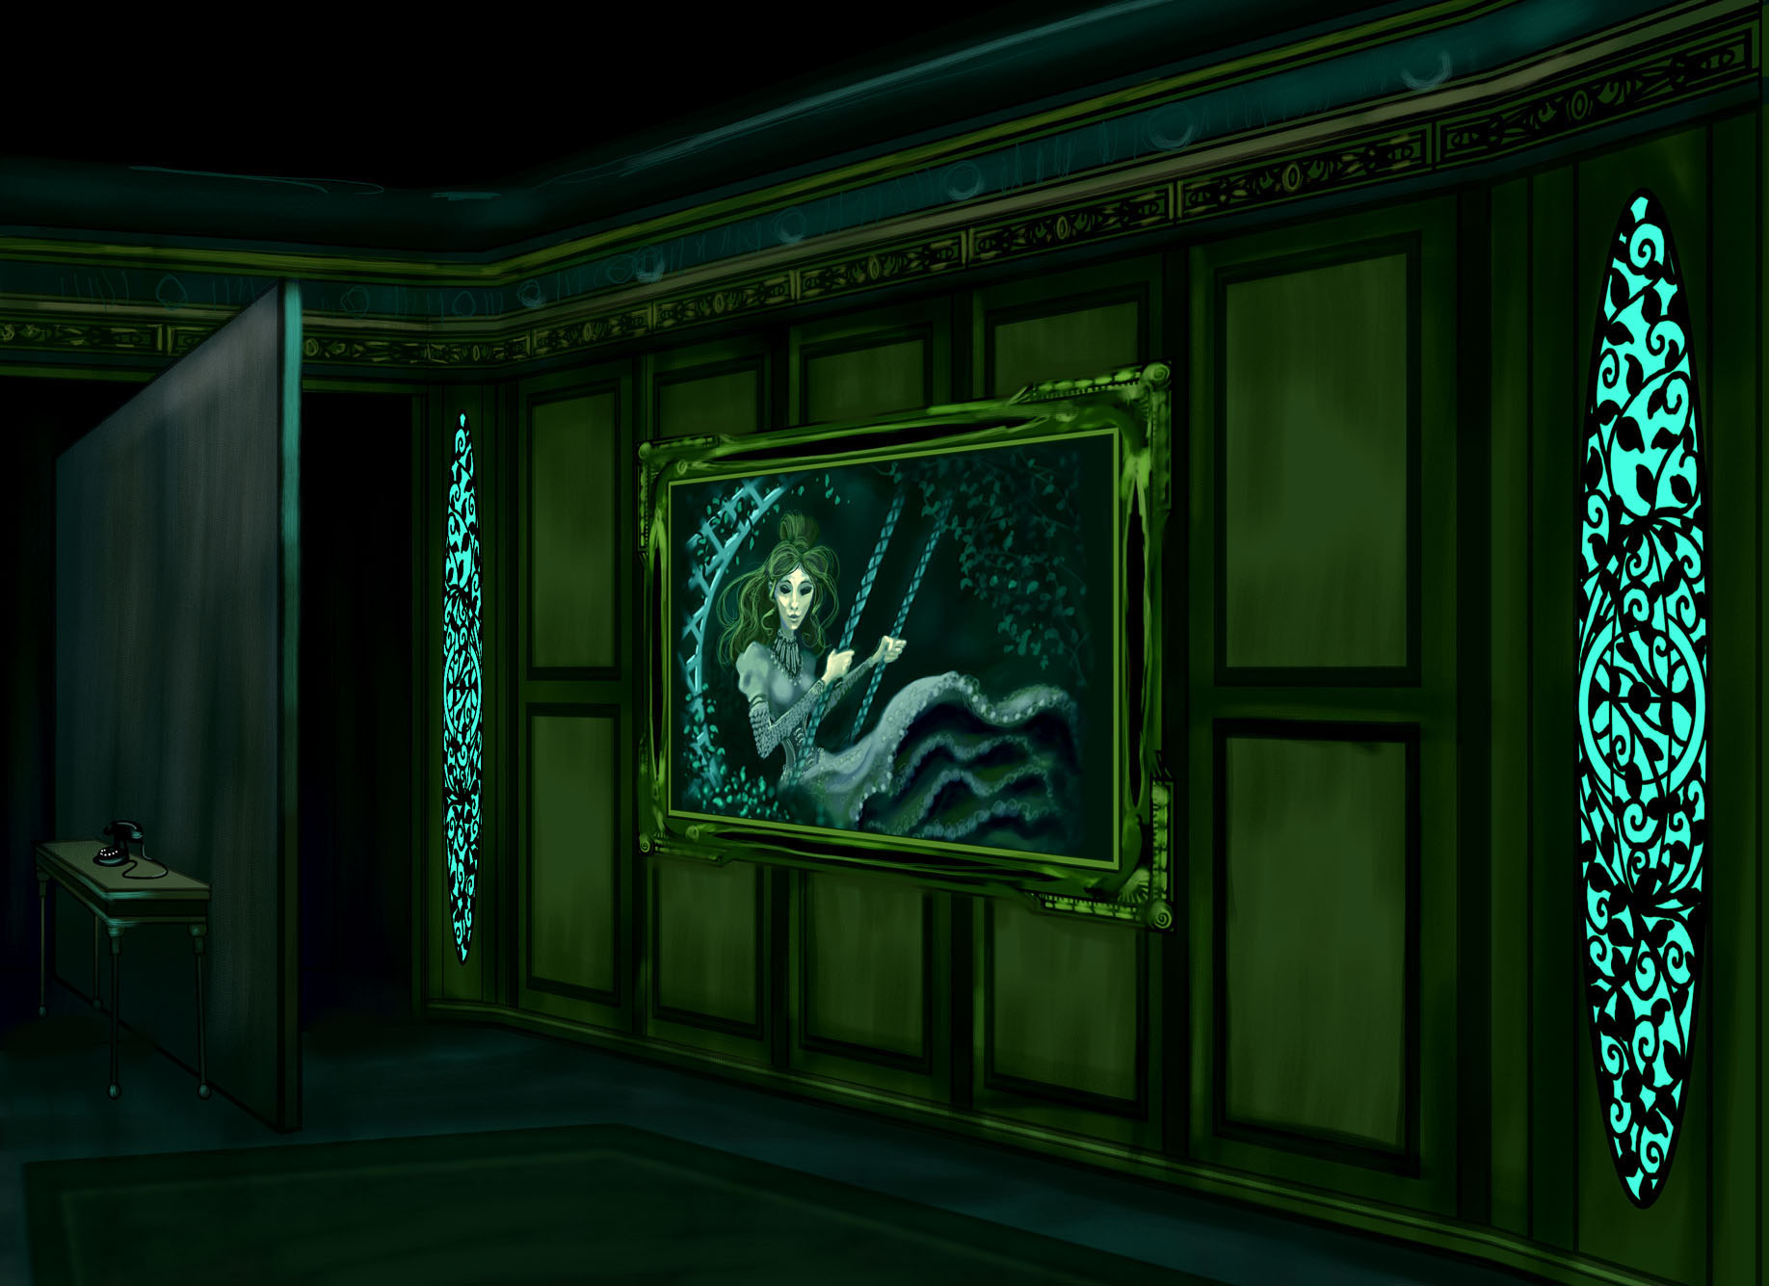
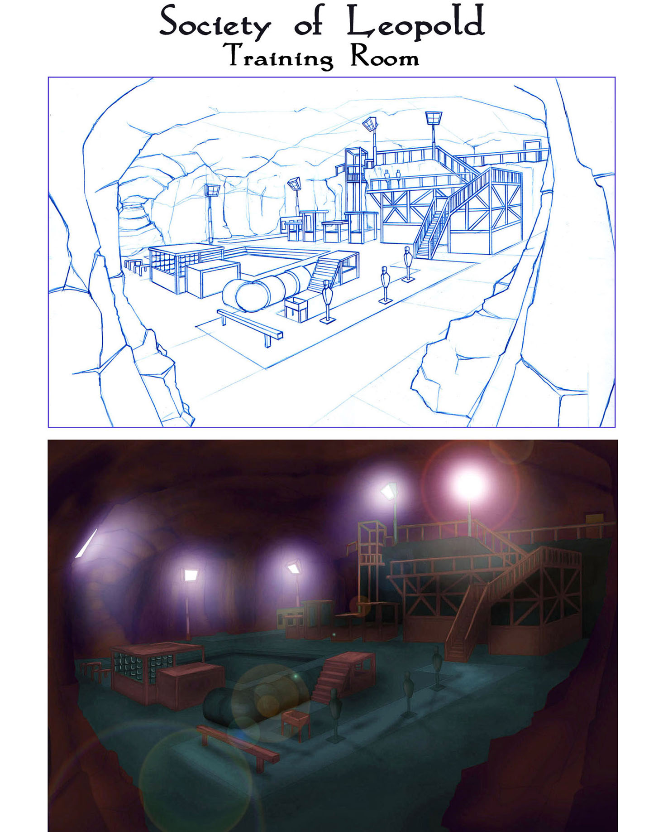
1. Phone triggers secret door at Grout's mansion.

2. Tubes used in Society of Leopold training room.

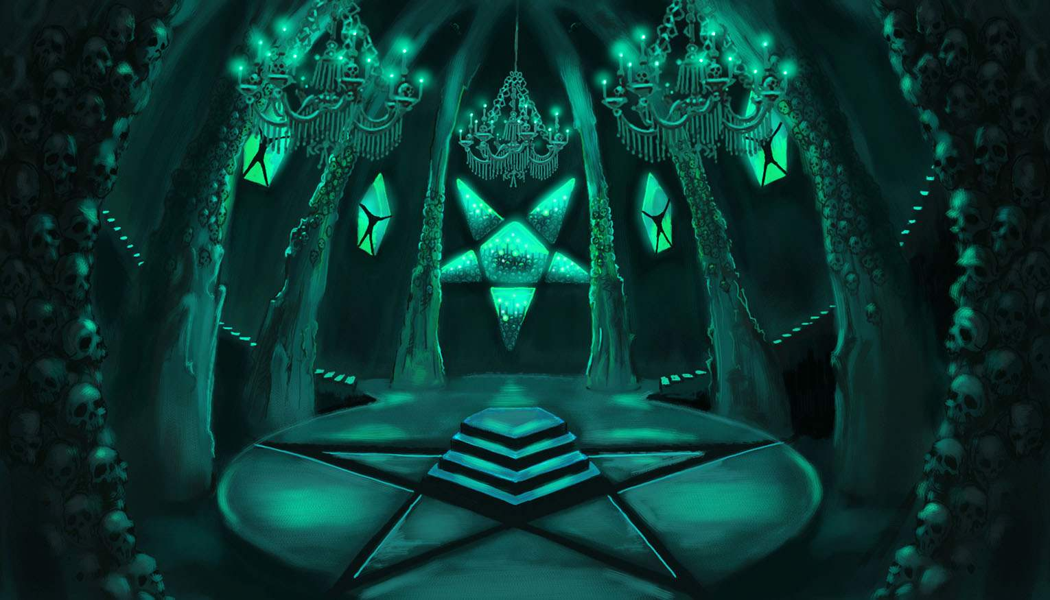

3. Ritual chamber under the public library in LA.

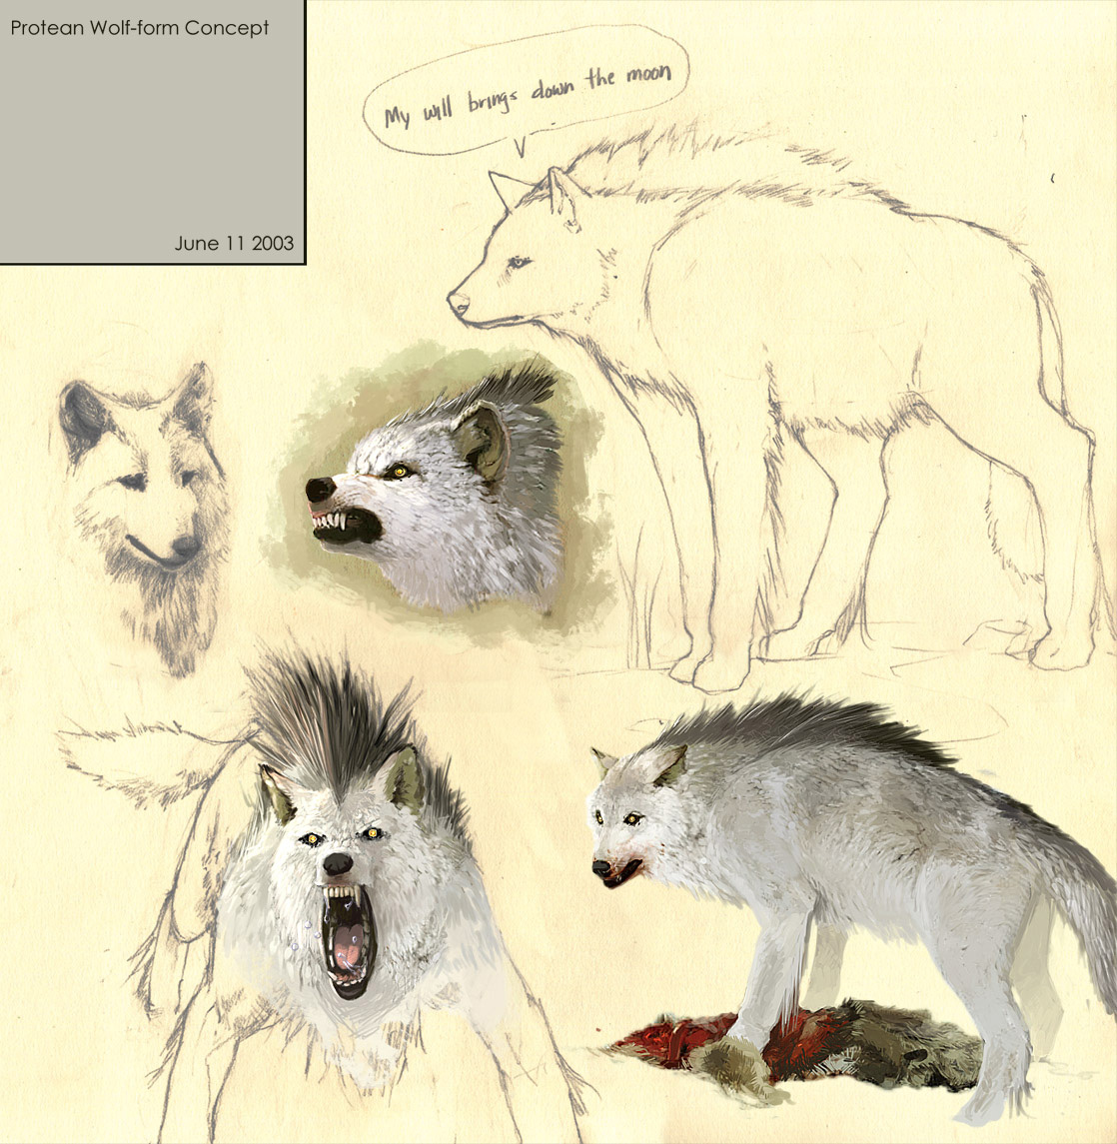
4. Protean warform using an actual wolf model.

